

1. ***Suggestions*** 
   1. From the point of view of UI it should be more acceptable to have Course Type, Discount, Course_count of the same size and format.
   2. Input fields of Course Type, Discount, Course_count can be of same size, as there is no need to have such a long field for inputting maximum three-digit number.
   3. It should be more user friendly to have a “%” sign near the Discount input field.
   4. In the Course type field it will be expedient to have one more option besides Advanced and Fundamental ones, which will include both courses. And we should have corresponding requirements for buying both types of Courses.
   5. Price should be shown already discounted according to the admin configuration. It shall be more convenient to have the initial price also displayed next to the discounted price in order to have clear understanding about the discount.
2. ***Requirement clarifications*** 
   1. By having numeric requirement for discount and count fields, will we accept as valid data decimal numbers?
   2. Do we consider that in the discount field acceptable numbers should be from 1 to 100?
   3. Shall we have maximum count of courses for entering in the field ‘Course_count’?
   4. Should not we have also requirements concerning the validation messages when entered data is invalid?
3. ***Bug reports***

**Bug ID:** 001

**Bug Summary:** The reaction of the Course type field when the 'Change discount' button is clicked.

**Environment/URL: https://qwallity-exam.herokuapp.com/**

**Operation System:** Windows 10

**Version**: 1

**Browser:** Google Chrome

**Submit Date:** 23/04/2022

**Reporter:** Zhenya Marutyan

**Steps to Reproduce:**

      1.The input fields of 'Change Discount' page are filled with valid data.

2. Course type is chosen Fundamental.

3. Press 'Change Discount' button.

**Expected Result:** After pressing 'Change discount' button, the Fundamental option of the course type field should not change automatically into Advanced.

**Actual Result:** After pressing 'Change discount' button, in all the fields the entered data stays the same, but the Fundamental option of the course type field is changed automatically into Advanced.

**Screenshot/video:** Screenshot is attached.

**Notes:** 1. https://qwallity-exam.herokuapp.com/ is open 2.Change discount page is opens.

**References:**

**Severity:** Medium

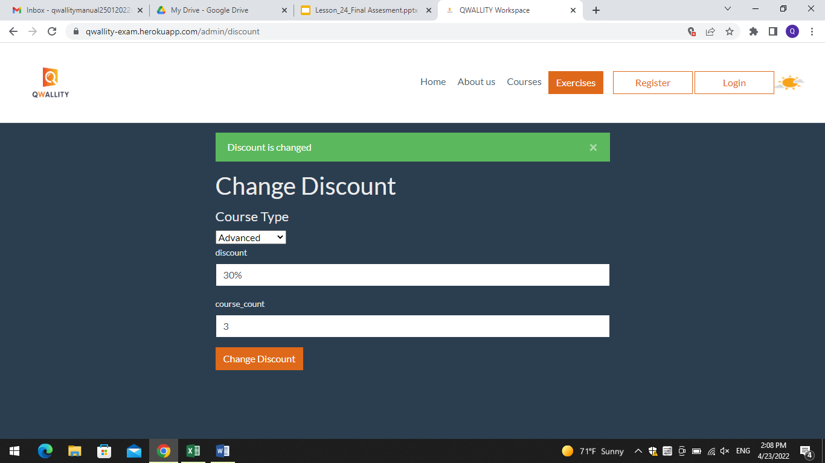

**Bug ID:** 002

**Bug Summary:** Discount field accepts letters, symbols, unlimited count of digits(>100) and empty field.

**Environment/URL: https://qwallity-exam.herokuapp.com/**

**Operation System:** Windows 10

**Version**: 1

**Browser:** Google Chrome

**Submit Date:** 23/04/2022

**Reporter:** Zhenya Marutyan

**Steps to Reproduce:**

1. In the discount field Enter non valid data: any letters, any symbols

2. Or leave the field empty.

**Expected Result:** Discount field should not accept letters, symbols, unlimited count of digits and empty field.

**Actual Result:** Discount field accepts letters, symbols, unlimited count of digits and empty field.

**Screenshot/video:** Screenshot is attached.

**Notes:** 1. https://qwallity-exam.herokuapp.com/ is open 2.Change discount page is opens.

3. Course type and course_count fields are filled with valid data.

**References:**

**Severity:** High

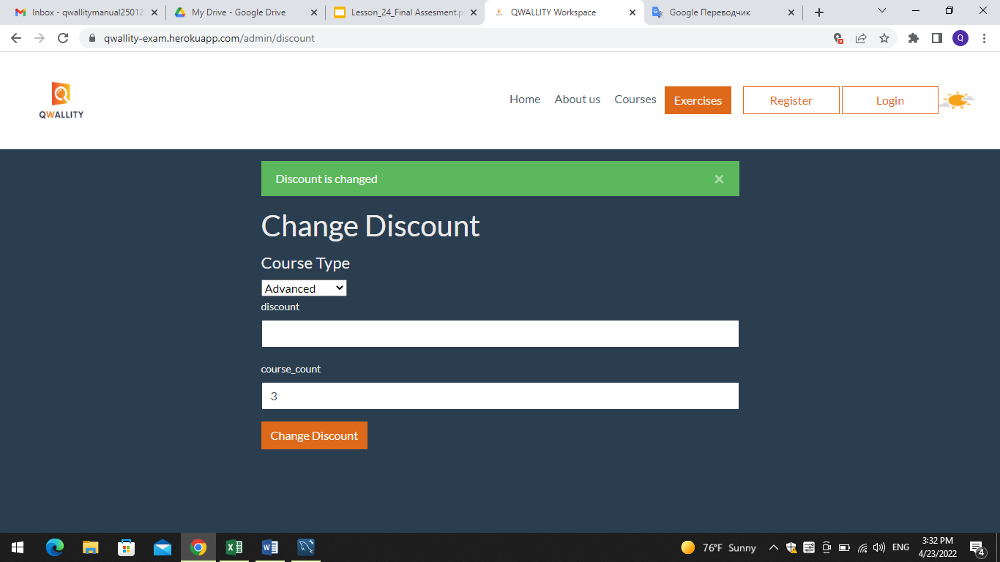

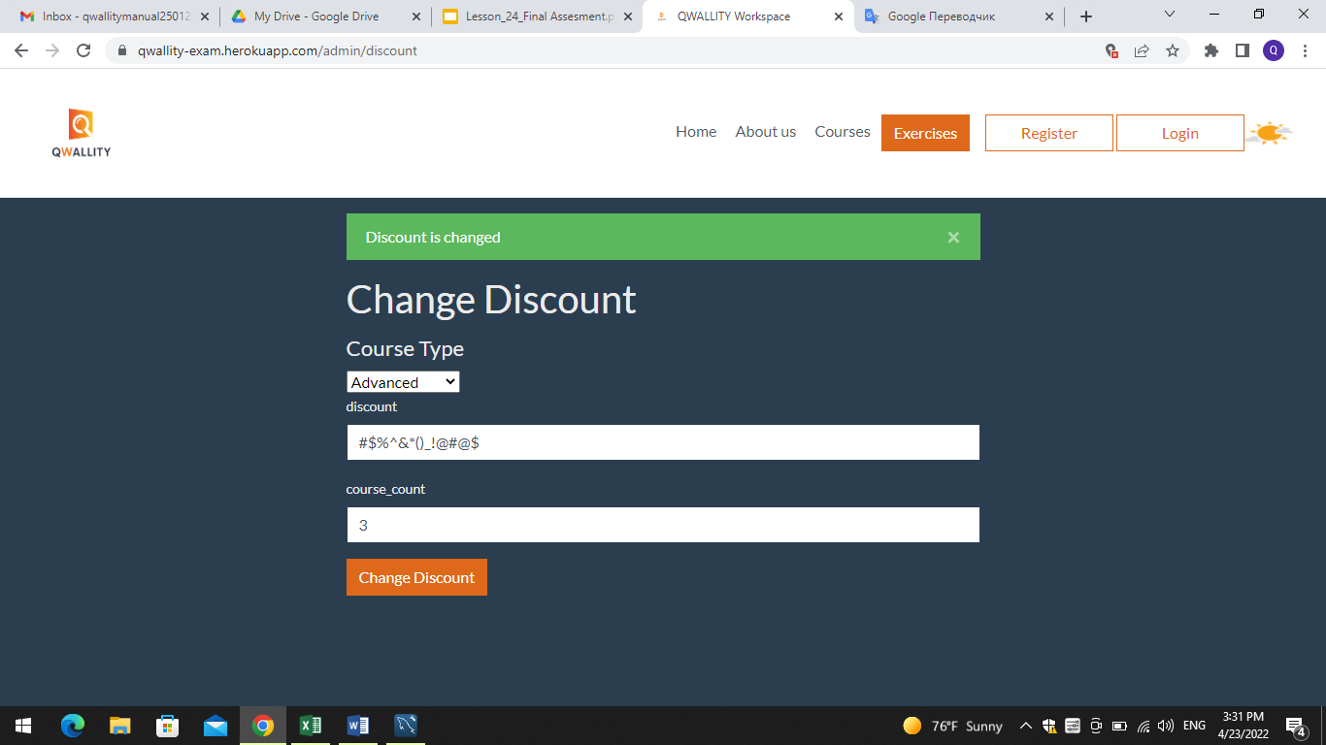

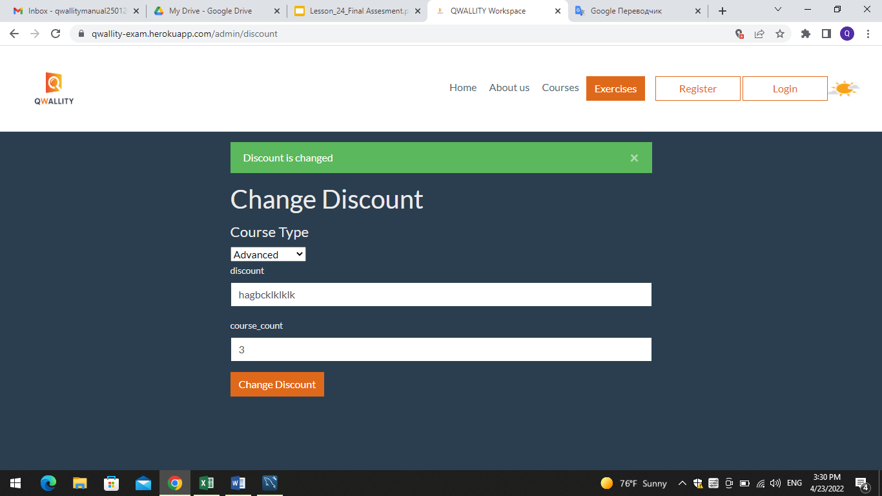

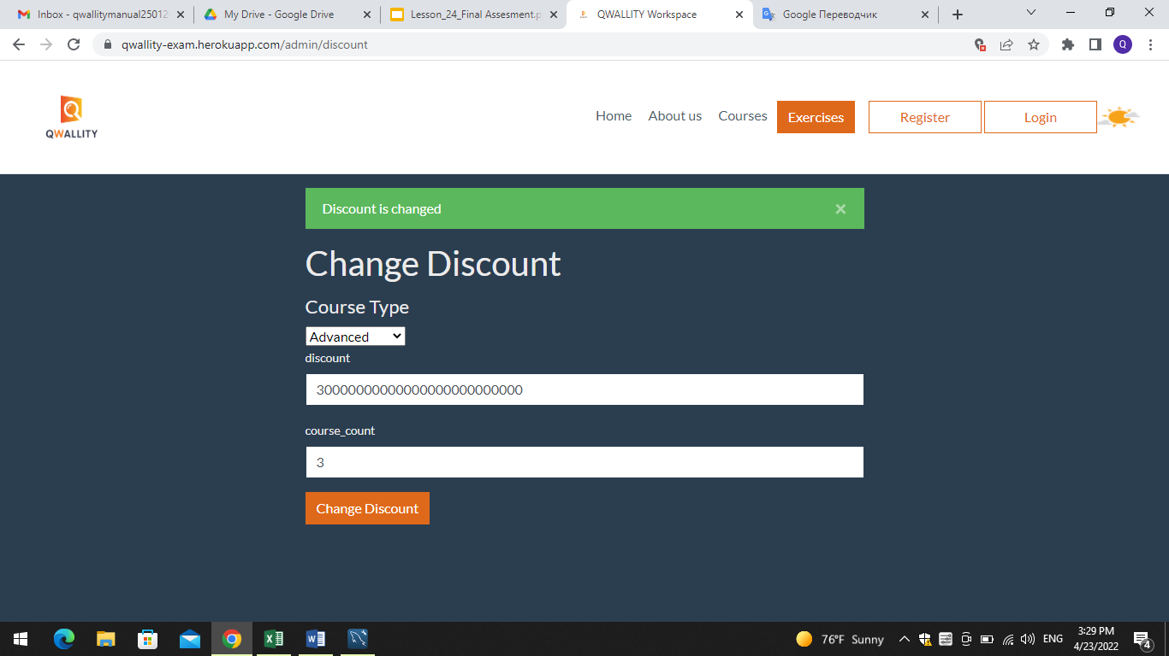

**Bug ID:** 003

**Bug Summary:** Course_count field accepts letters, symbols, unlimited count of digits(>100) and empty field.

**Environment/URL: https://qwallity-exam.herokuapp.com/**

**Operation System:** Windows 10

**Version**: 1

**Browser:** Google Chrome

**Submit Date:** 23/04/2022

**Reporter:** Zhenya Marutyan

**Steps to Reproduce:**

1.In the discount field Enter non valid data: any letters, any symbols

2. Or leave the field empty.

**Expected Result:** Course_count field should not accept letters, symbols, unlimited count of digits and empty field.

**Actual Result:** Course_count field accepts mentioned invalid data.

**Screenshot/video:** Screenshot is attached.

**Notes:** 1. https://qwallity-exam.herokuapp.com/ is open 2.Change discount page is opens.

3. Course type and discount fields are filled with valid data.

**References:**

**Severity:** High

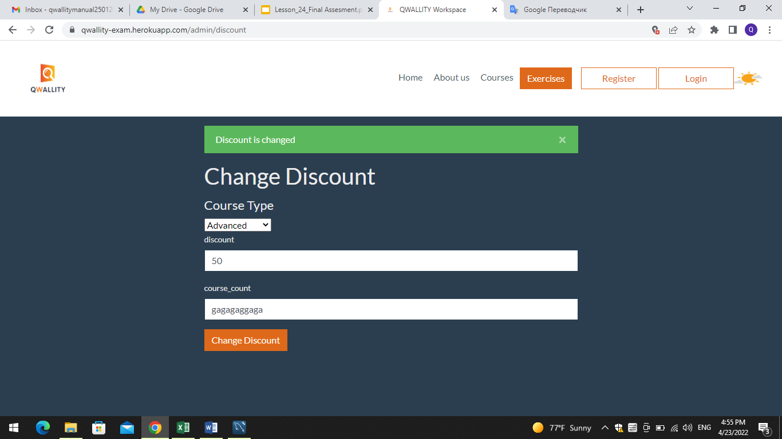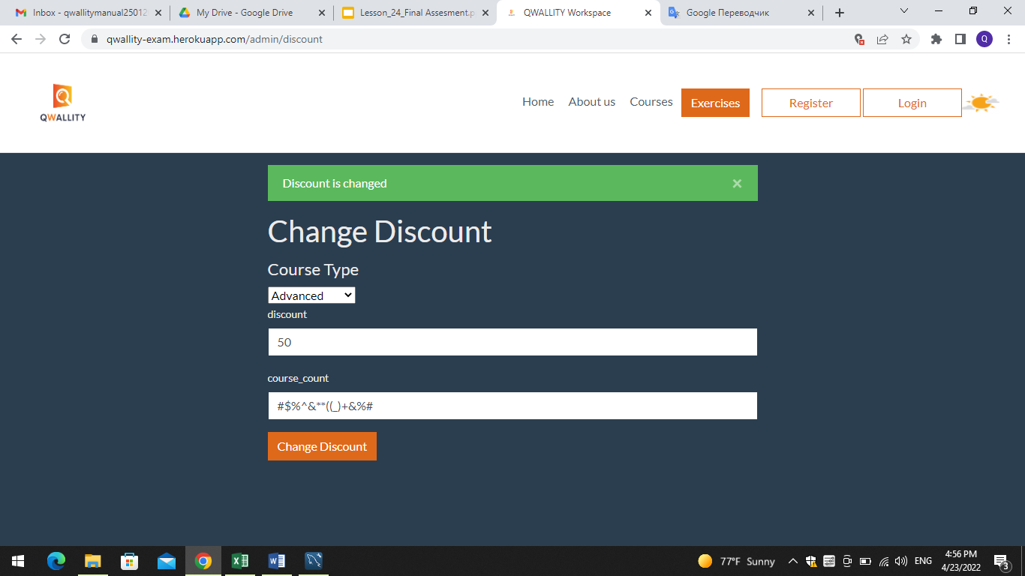

**Bug ID:** 004

**Bug Summary: A**fter pressing change discount button (submission), notification is appearing on the page.

**Environment/URL: https://qwallity-exam.herokuapp.com/**

**Operation System:** Windows 10

**Version**: 1

**Browser:** Google Chrome

**Submit Date:** 23/04/2022

**Reporter:** Zhenya Marutyan

**Steps to Reproduce:** Press the Change discount button.

**Expected Result:** The following notification should appear– ‘Discount changes’

**Actual Result:** The following notification appears-'Discount is changed'

**Screenshot/video:** Screenshot is attached.

**Notes:** 1. https://qwallity-exam.herokuapp.com/ is open 2.Change discount page is opens.

3. All the fields are filled with valid data.

**References:**

**Severity:** Low

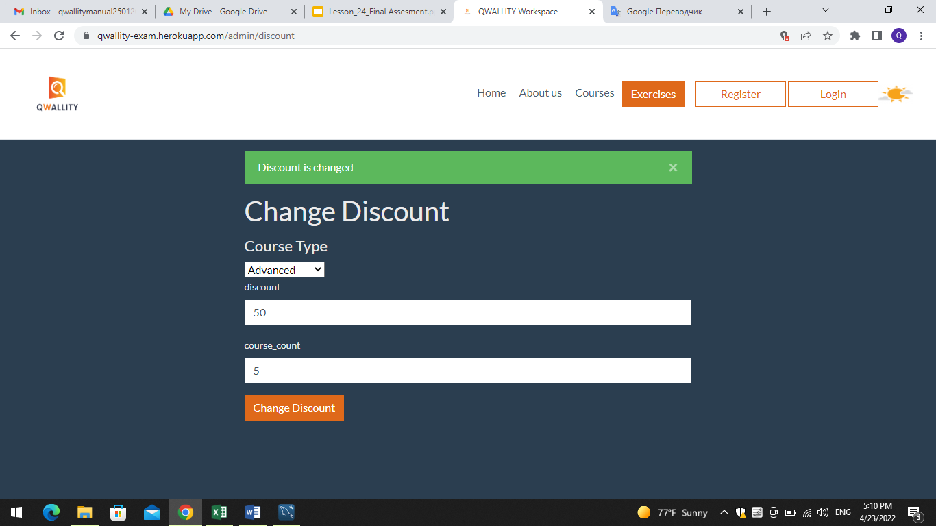

**Bug ID:** 005

**Bug Summary:** Discount аpplicability when Non admin user buys both Advanced and Fundamental courses.

**Environment/URL: https://qwallity-exam.herokuapp.com/**

**Operation System:** Windows 10

**Version**: 1

**Browser:** Google Chrome

**Submit Date:** 23/04/2022

**Reporter:** Zhenya Marutyan

**Steps to Reproduce:** 1. Buy 2 Fundamental Courses

2. Then buy 1 Advanced course.

**Expected Result:** There should be no discount for 1st bought Advanced course.

**Actual Result:** The discount for 1st bought Advanced course is 30%.

**Screenshot/video**

**Notes:** Admin user has set 20% discount in case of buying 2 Fundamental Courses and 30% in case of buying 2 Advanced courses.

**References:**

**Severity:** High

**Bug ID:** 006

**Bug Summary:** Notification after buying correspondant number of courses.

**Environment/URL: https://qwallity-exam.herokuapp.com/**

**Operation System:** Windows 10

**Version**: 1

**Browser:** Google Chrome

**Submit Date:** 23/04/2022

**Reporter:** Zhenya Marutyan

**Steps to Reproduce:** Press the Change discount button.

**Expected Result:** Notification- ’You have xxx discount. Discounted price displays.’

**Actual Result:** Notification- ’You have xxx discount. Discounted price is displayed.’

**Screenshot/video:** Screenshot is attached.

**Notes:** Courses are bought successfully.

**References:**

**Severity:** low

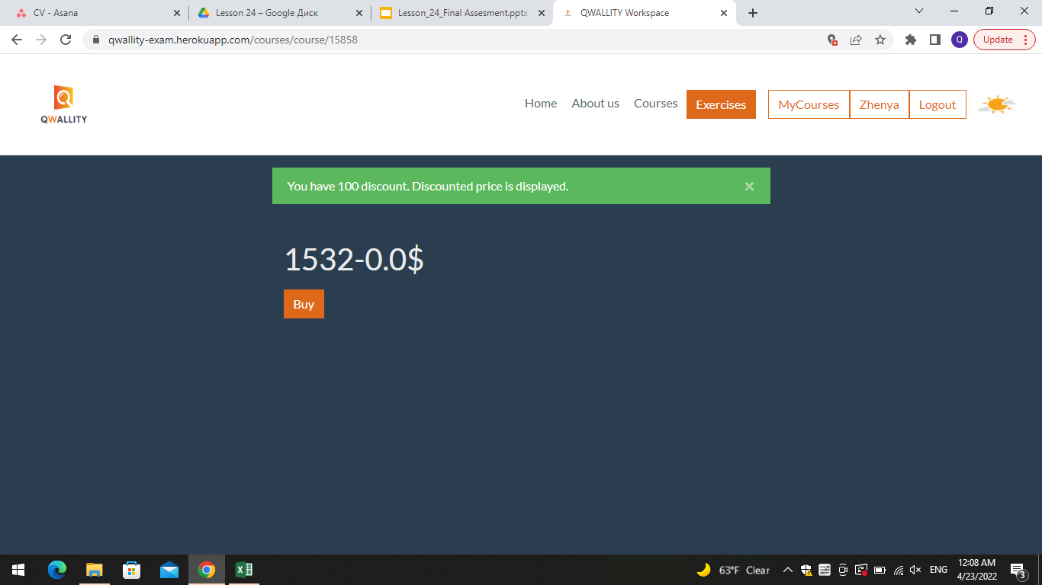

**Bug ID:** 007

**Bug Summary:** Validation message in case of invalid data input in the discount and course_count fields.

**Environment/URL: https://qwallity-exam.herokuapp.com/**

**Operation System:** Windows 10

**Version**: 1

**Browser:** Google Chrome

**Submit Date:** 23/04/2022

**Reporter:** Zhenya Marutyan

**Steps to Reproduce:**

1. Enter invalid data:

Discount: aaaaaaaaaa

Course_Count: ccccccccccccc

2. Press the Change discount button.

**Expected Result:** There should be Backend or Frontend Validation messages in case of invalid data input in the discount and course_count fields.

**Actual Result:** There is no Validation message in case of invalid data input in the discount and course_count fields.

**Screenshot/video:** Screenshot is attached.

**Notes:** Invalid data is entered into discount and course_count fields.

**References:**

**Severity:** medium

